
DAFFODIL INTERNATIONAL UNIVERSITY
FYDP (Phase-I) Progress Report
Reporting Period- Summer 2025
Project Identification:
I. Project Title | A Deep Learning Approach for the Coconut Tree Disease Detection.
II. Group Members | - Name: Munna Biswas Student ID: 221-15-5261  - Name: Md. Monowar Hossain Student ID: 221-15-5366
III. Supervisor | Name: Dr. Abdus Sattar  Designation: Assistant Professor
IV. Co-Supervisor | Name: Arpita Ghose Tusi  Designation: Lecturer
V. Submission Date:
VI. Certificate : | “This is to certify that the final year design project work until Phase-I evaluation held on ___________________, titled as stated in Sec. I, executed by the students’ group mentioned in Sec. II, have been found satisfactory and every section of this report is reflecting the same.” | (Signature of Supervisor & date)

Project Insights
Thematic Area(s):  [Just click the check box] | Artificial Intelligence and Machine Learning | 
Thematic Area(s):  [Just click the check box] | Data Science and Analytics | ☐
Thematic Area(s):  [Just click the check box] | Cybersecurity | ☐
Thematic Area(s):  [Just click the check box] | Software Engineering and Development | ☐
Thematic Area(s):  [Just click the check box] | Blockchain Technology | ☐
Thematic Area(s):  [Just click the check box] | Internet of Things (IoT) | ☐
Thematic Area(s):  [Just click the check box] | Computer Networks | ☐
Thematic Area(s):  [Just click the check box] | Human-Computer Interaction (HCI) | ☐
Thematic Area(s):  [Just click the check box] | Big Data Technologies | ☐
Thematic Area(s):  [Just click the check box] | Computer Vision
Thematic Area(s):  [Just click the check box] | Natural Language Processing (NLP) | ☐
Thematic Area(s):  [Just click the check box] | Robotics | ☐
Thematic Area(s):  [Just click the check box] | Game Development | ☐
Thematic Area(s):  [Just click the check box] | Cloud Computing | ☐
Thematic Area(s):  [Just click the check box] | Biomedical Computing | ☐
Thematic Area(s):  [Just click the check box] | Others (please specify):
Software packages, tools, and programming languages | Programming Language: Python  Environment: Google Colab  Package List:  1. NumPy  2. Pandas  3. Matplotlib  4. Seaborn  5. Scikit-learn  6. TensorFlow  7. Keras  8. OpenCV

CO Description for FYDP-Phase-I
CO | CO Descriptions | PO
CO1 | Integrate recently gained and previously acquired knowledge to identify a Deep Learning Approach for the Coconut Tree Disease Detection problem for the Final Year Design Project (FYDP). | PO1
CO2 | Analyze different aspects of the goals in designing a solution for the FYDP. | PO2
CO3 | Explore diverse problem domains through a literature review, delineate the issues, and establish the goals for the FYDP | PO4
CO4 | Perform economic evaluation and cost estimation, and employ suitable project management procedures throughout the FYDP lifecycle in the context of developing the “Deep Learning Approach for the Coconut Tree Disease Detection”. | PO11
CO6 | Select and apply appropriate methodologies, resources, and contemporary engineering/IT tools for prediction modeling and solving complex engineering processes for the “Deep Learning Approach for the Coconut Tree Disease Detection”. | PO5
CO7 | Assess societal, health, safety, legal, and cultural issues and responsibilities in professional engineering practice related to the FYDP problem. | PO6
CO10 | Operate effectively as an individual and as a member/leader in multidisciplinary teams during FYDP. | PO9

- Project Overview:
  - Introduction
Coconut is one of the most important tropical crops cultivated for food, oil, and raw materials. However, various leaf diseases such as Bud Rot, Leaf Rot, Yellow Leaf Disease, and Gray Leaf Spot, along with tree body diseases like Stem Bleeding, significantly reduce productivity, affect crop yield, and lower farmer income. Early and accurate detection of such diseases is critical for timely intervention and sustainable agriculture. Traditional manual detection methods are often time-consuming, labor-intensive, and prone to human error.
In this project, we aim to build a deep learning-based image classification system that can automatically detect coconut tree diseases from images. By leveraging convolutional neural network (CNN) architectures, Explainable AI (XAI) techniques will be incorporated to make predictions transparent and interpretable for end-users. In the future, the system will be extended into a mobile or web-based application, providing farmers and agricultural professionals with precise, scalable, and real-time diagnostic support.

  - Background
Coconut farming is a vital economic activity in many tropical countries, including Bangladesh, India, Sri Lanka, and the Philippines. However, the productivity and sustainability of coconut plantations are under constant threat due to diseases and pest infestations. Leaf diseases such as Bud Rot, Leaf Spot, Stem Bleeding, and infections caused by pests like the Red Palm Weevil can lead to significant crop losses and economic damage [1], [2], [3].
Traditionally, the identification of these diseases relies on manual inspection by experts, which is often inaccurate, subjective, and time-consuming. The diversity in leaf damage patterns, overlapping symptoms, and environmental interference makes disease identification even more complex. This results in delayed treatment and further spread of infections within plantations [5], [6].
Recent advancements in artificial intelligence (AI), particularly in deep learning and computer vision, offer a promising alternative to manual inspection. Deep learning models such as Convolutional Neural Networks (CNNs), ResNet50, DenseNet121, YOLOv4, and MobileNetV2 have been successfully applied for disease detection and classification from plant leaf images, achieving accuracies as high as 99% [4], [5], [6]. These models excel in feature extraction and pattern recognition, enabling them to detect subtle changes in color, texture, and shape that are often missed by the human eye.
In parallel, datasets such as the Coconut Tree Disease Dataset, containing thousands of labeled images, have been curated to support the training and evaluation of such models [7], [8]. These image datasets cover various disease categories, including Bud Rot, Gray Leaf Spot, and Stem Bleeding, and provide a comprehensive foundation for deep learning applications in agriculture.
Moreover, innovative architectures like EfficientNet, YOLOv4, and Capsule Networks have demonstrated improved performance in real-time applications by balancing model complexity and speed [7], [9], [12]. Coupled with cloud computing and mobile deployment frameworks, these AI models can be integrated into portable tools for on-field disease detection. The incorporation of explainable AI techniques also enhances user trust and helps bridge the gap between technology and traditional farming practices [12], [20].
Several studies have explored pest detection and severity classification using image-based segmentation methods like K-means clustering, thresholding, and watershed algorithms [2], [10], [13]. These segmentation techniques enable precise identification of infected regions, facilitating targeted interventions.
In the broader context, the rise of smart agriculture has underscored the value of AI-driven disease detection systems in enhancing food security, minimizing crop loss, and promoting sustainable farming. This project, therefore, aims to contribute to this evolving field by developing a real-time, image-based disease detection system specifically tailored for coconut plantations, which remain underrepresented in current agricultural technology solutions [6], [21], [24].

1.3 Summary of related works:
Reference | Methodology  Used | Dataset Used | Classified Classes | Findings
  Limitations
[1] | YOLOv4 | Self-collected leaf disease dataset | Yellowing,  Drying,  Pest Infections,  Flaccidity | 88% F1-Score  85% Mean Average Precision | Lower accuracy, sensitive to image noise
[2] | Custom CNN | Hand-collected data | Stem Bleeding, Leaf Blight, Pest Infection | validation accuracy 96.94% | Limited dataset size; lacks variety in environmental conditions
[4] | VGG16  ResNet50  MobileNetV2 | Hand-Collected Dataset | Bud Root Dropping, Bud Rot, Gray Leaf Spot, Leaf Rot, Stem Bleeding | Accuracy  88%  94%  92% | Imbalance Dataset
[9] | DCNN | Drone-based image dataset | Root Bleeding, Polluted Blades, Insect Infestation | New perspectives for surveillance | Computationally intensive. Limited large-scale testing
[12] | Inception V3 model | Public Dataset | Leaf Spot, Leaf Blight, Grey Leaf Spot, Root Wilt, Stem Bleeding, Stem Rot | Accurate real-time prediction | Integrating XAI improves trust but increases processing time
[25] | MobileNetV2 | Collected from multiple public datasets | Coconut Leaf Disease, Coconut Disease | accuracy 99.2% | Risk of overfitting without augmentation; needs real-world testing
[29] | VGG | Public dataset | Grape Leaves Disease, Tomato Leaves Disease | Accuracy  98.40%  95.71% | Not coconut-specific. accuracy may drop on coconut images.

- Objectives:
This study aims to develop a deep learning-based system for the accurate and early detection of coconut tree diseases, helping reduce crop loss and supporting farmers with an accessible solution. The primary objectives of this study are as follows:

- To Develop a deep learning-based image classification system to detect coconut leaf and stem diseases, including Bud Rot, Leaf Rot, Yellow Leaf Disease, Gray Leaf Spot, Stem Bleeding, and Coconut Caterpillar.

- To Evaluate and compare the performance of multiple CNN-based architectures to identify the most accurate and robust model.

- To Integrate Explainable AI (XAI) techniques, such as Grad-CAM, to make model predictions transparent and interpretable for end-users.

- To Visualize the model training progress and results using accuracy and loss curves, along with performance metrics like confusion matrices and classification reports.

- To Prepare the best-performing model for future deployment in a mobile or web-based application for real-time, field-level disease detection.

- Methodology:

  - Research Design
Our study is focused on finding an efficient and automated approach for detecting diseases in coconut trees, particularly through the use of deep learning techniques. Given the agricultural importance of coconut in tropical regions and the significant losses caused by leaf diseases, it is essential to explore a reliable classification system that can work under real-world conditions. Our model is designed to identify six common diseases through visual features extracted from leaf images. To achieve this, we adopted a method based on transfer learning where well-established architectures such as Sequential_5, DenseNet121, and ResNet50 were employed.

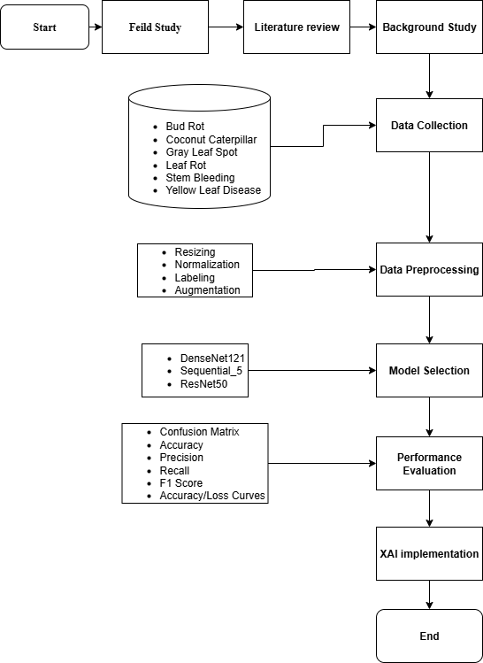

Figure 3.1: Work Flow Diagram
We used a dataset consisting of 6000 labeled images, already augmented and divided into six classes. The data was prepared by resizing images to 224x224 pixels and normalizing pixel values between 0 and 1. The pre-trained models were then fine-tuned using this dataset to maximize classification accuracy. The experiments were conducted on Google Colab using a GPU runtime. The Python programming language served as the primary development environment, with the help of deep learning libraries such as TensorFlow and Keras. Visualization and evaluation were carried out using libraries like Matplotlib, Seaborn, and Scikit-learn. These tools provided a robust, user-friendly environment that allowed efficient model development and iteration.

  - Data Collection
For this study, we utilized a publicly available image dataset hosted in Google Drive, which includes 6000 labeled coconut leaf images. These images are categorized into six major classes representing different types of coconut diseases, such as Bud Rot, Leaf Rot, Gray Leaf Spot, Stem Bleeding, Yellow Leaf Disease, and Coconut Caterpillar.
The dataset had been previously cleaned and augmented to ensure balanced class distribution and better model generalization. It includes a variety of leaf conditions captured under different lighting and background conditions, mimicking real-world field scenarios. The need for such a dataset arises from the lack of accessible and annotated coconut leaf disease images. By leveraging this curated collection, we are able to train and validate high-performance models without the need for additional manual data collection, which is time-consuming and resource-intensive. This dataset serves as the foundation for developing a scalable and practical disease detection system for farmers and agricultural experts.

  - Analysis Techniques
The dataset is mainly a combination of two coconut disease datasets. This concludes in 6 diseases. The following are the two datasets:
1. 4000 data is from Coconut Tree Disease (Bud_Rot, Steem_Bleeding, Gray_Leaf_Spot, Leaf_Rot)
2. 2000 data is from Coconut Diseases and Pest Infestations (Caterpillars, Yellow Leaf)

After being processed by the ImageDataGenerator, all data was converted into integers, as Figure 3.2 shows.
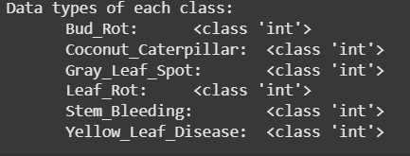

Figure 3.2: Data Types

We can see that the dataset has 6 classes. Figure 3.3 shows the balanced distribution across six disease categories.
y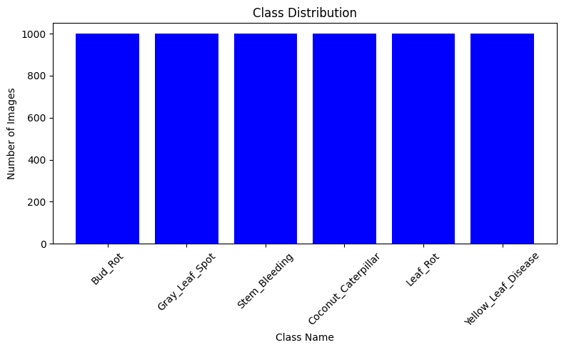

Figure 3.3: Distribution of classes

Figure 3.4 visualizes one random sample image from each class.
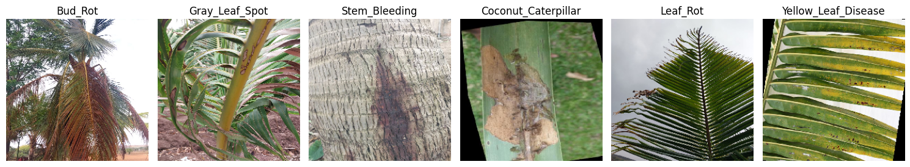
Figure 3.4: Sample images

To visualize the dataset and analyze its properties, we plotted the distribution of each class, verified the image data formats, and examined sample images. The images were processed using TensorFlow pipelines.
These techniques ensured data consistency, enabled robust training, and provided useful visualizations that support a deeper understanding of the classification problem.

- Progress Achieved:
  - Completed Tasks
4.1.1 Data Collection and Preprocessing:
Collected a high-quality image dataset comprising 6000 coconut leaf images, with 1000 images per class representing six common diseases: Bud Rot, Coconut Caterpillar, Gray Leaf Spot, Leaf Rot, Stem Bleeding, and Yellow Leaf Disease. The dataset was curated and organized to ensure proper labeling and balance across all categories
Preprocessing steps were carried out to standardize the input for model training. Each image was resized to 224x224 pixels and normalized to a pixel intensity range of 0 to 1. This was essential for ensuring consistency and compatibility with pre-trained CNN models. Augmentation had already been applied to improve the dataset's robustness against overfitting.

4.1.2 Model Selection and Training:
After evaluating various CNN architectures, we selected three high-performing models, Sequential_5, DenseNet121, and ResNet50, for detailed experimentation. These models were chosen based on their proven performance in image classification tasks and their availability in transfer learning libraries.
Training was conducted on Google Colab using a GPU runtime to accelerate processing. Transfer learning was implemented by freezing base layers and training top layers on the coconut dataset. A training-validation split was used to monitor generalization, and techniques such as learning rate scheduling were applied to optimize performance.

4.1.3 Initial Testing and Evaluation:
Each model was evaluated using comprehensive metrics, including accuracy, precision, recall, F1-score, and confusion matrix. This allowed us to assess the model's ability to distinguish between similar leaf disease categories.
Additionally, training accuracy and loss values were visualized for each epoch using Matplotlib, providing insight into model behavior and convergence. The DenseNet121 model emerged as the top performer with a validation accuracy of 95.25%, followed closely by Sequential_5 (92.53%), but ResNet50 achieved comparatively low accuracy (79.67%).

4.1.4 Model Saving and Documentation:
Saved all the models to Google Drive.
Documented all preprocessing, training processes, and results for further reference.

  - Results Obtained
4.2.1 Model Accuracy:
DenseNet121 achieved a training accuracy of 99.94% and a validation accuracy of 95.25% in detecting coconut leaf diseases. This highlights DenseNet121's efficiency in capturing complex visual patterns associated with different coconut leaf diseases. Figure 4.1 shows the line graph for the model’s accuracy and loss.
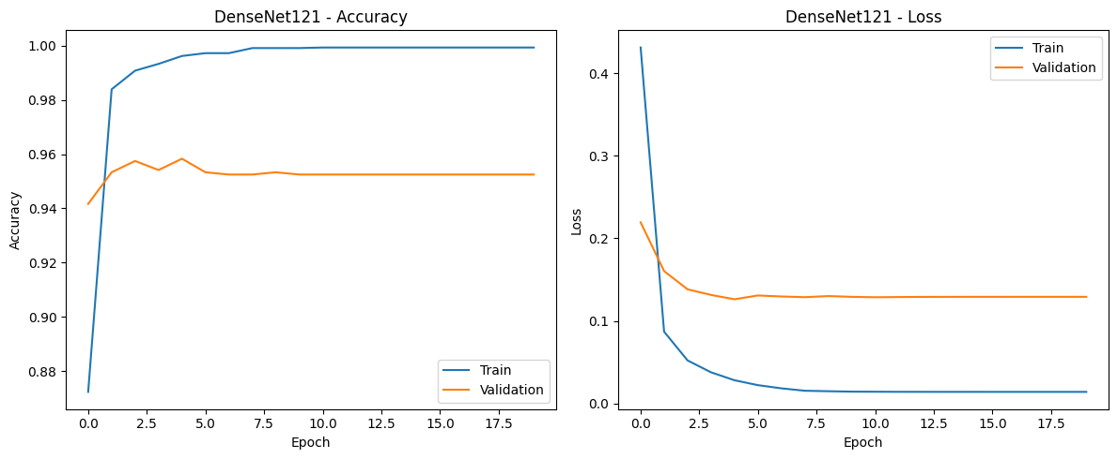
Figure 4.1: Line graph of Accuracy and Loss
4.2.2 Insights from Classification:
Visually distinct diseases like Yellow Leaf Disease, Coconut Caterpillar, Stem Bleeding were identified with high confidence, although a few misclassifications were observed. These insights support the robustness of DenseNet121 in managing a diverse range of visual symptoms.

4.2.3 Confusion Matrix Results:
The model showed strong classification performance with a high true positive rate and minimal false predictions shown in Figure 4.2.
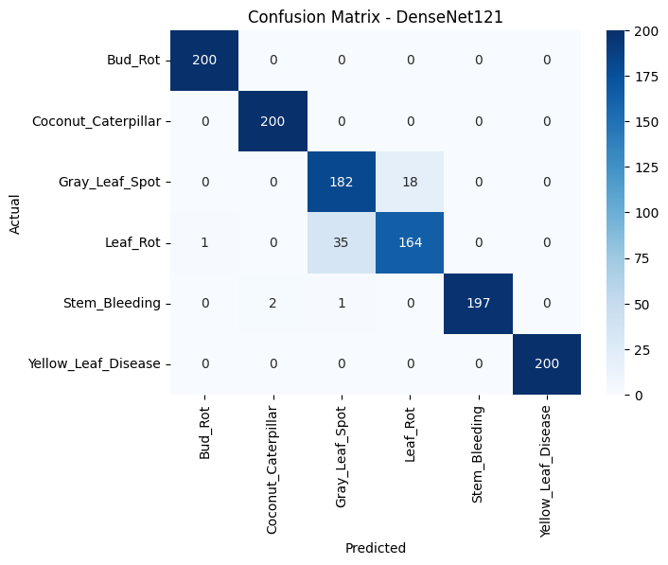

Figure 4.2: Confusion Matrix

4.2.4 Deployment Potential:
The results indicate strong potential for real-time and in-field implementation of the model. Its accuracy, stability during training, and ability to generalize across varying lighting conditions make it suitable for mobile or web-based diagnostic tools. These findings are highly promising for farmers and agricultural professionals aiming to detect diseases early and take appropriate countermeasures.
- Challenges Faced:
S.No. | Issues and Challenges | Strategies or Plans
1 | The dataset contained similar visual features across multiple disease categories, which led to occasional misclassification. | Carefully analyzed sample images and used data preprocessing techniques to enhance inter-class variation and generalization during training.
2 | Training large models like DenseNet121 on Google Colab resulted in GPU memory limitations and interrupted sessions. | Reduced batch size, optimized image resolution. Models were saved at checkpoints to avoid data loss.
3 | The model achieved high training accuracy but risked overfitting due to the limited diversity in image backgrounds. | Applied dropout layers, early stopping, and image augmentation (e.g., zoom, flip, rotation) to reduce overfitting and improve generalization.
4 | Evaluation metrics were initially limited to accuracy, which didn’t reflect true performance on complex classes. | Added precision, recall, F1-score, and confusion matrix to gain better insights into model behavior for each class.

- Next Steps:
S.No. | Next Task | Estimate completion time  (MM-YY)
1 | Fine-tune the DenseNet121 model to further improve accuracy and F1 score, aiming for greater precision and fewer false predictions. | AUG-25
2 | Develop a custom CNN model with hyperparameter tuning (learning rate, dropout, batch size) to finalize the best-performing configuration. | SEP-25
3 | Integrate Explainable AI techniques (e.g., Grad-CAM, LIME) to visualize and interpret model predictions, ensuring transparency and trust in results. | OCT-25
4 | Prepare comprehensive documentation, including training methodology, performance evaluation, and class-wise confusion matrix insights. | NOV-25

- Updated Timeline:
- Provide an updated timeline, highlighting progress made and indicating any adjustments.
Tasks | Weeks
 | 6 | 7 | 8 | 9 | 10 | 11 | 12 | 13 | 14 | 15 | 16 | 17 | 18 | 19 | 20 | 21 | 22 | 23
Performance Tuning
Hyperparameter Optimization
Integrate XAI techniques
Final Documentation

Estimated Work Period
Actual Work Period

- Resources Utilized:

8.1 Coconut Leaf Disease Dataset:
A pre-augmented image dataset stored in Google Drive, consisting of 6000 labeled images categorized into six major coconut leaf diseases: Bud Rot, Coconut Caterpillar, Gray Leaf Spot, Leaf Rot, Stem Bleeding, and Yellow Leaf Disease.

8.2 Data Storage:
Cloud-based storage (Google Drive) was used to manage and access large volumes of image data efficiently during training and evaluation.

8.3 Python Environment:
Python was used for developing the deep learning models, training workflows, and visualizations. Development was conducted in Google Colab using GPU runtime.

8.4 Python Libraries and Tools:

- NumPy and Pandas: For handling image metadata, preprocessing, and managing training logs.
- Matplotlib and Seaborn: For visualizing training accuracy/loss, class distributions, and confusion matrices.
- TensorFlow and Keras: For building and training deep learning models using transfer learning with CNN architectures like DenseNet121.
- Scikit-learn: For performance evaluation using metrics like accuracy, precision, recall, F1-score, and confusion matrix.
- Google Colab Notebooks: Provided an interactive and collaborative environment for coding, model experimentation, and documentation.

- Project Management and Financial Analysis:
SN | Components | Estimated Cost (BDT)
01 | Internet and Power Backup | 1500 – 2000
02 | Cloud Storage and Compute (Google Drive, Colab Pro) | 0 – 1000
03 | Tools & Equipment (Laptop, Mobile Camera, etc.) | 4500 – 6000
04 | Software Libraries and Environments (Python, TensorFlow – mostly open-source) | Free – 1000
05 | Documentation and Report Writing | 500 – 1000
06 | Miscellaneous (Transport, printing, etc.) | 500 – 1000
07 | Contingency (10% of total) | 1000 – 1500
 | Total Estimated Cost | 10,000 – 13,500

- Future Considerations:
- In the next phase, key challenges and enhancements will be addressed:
- Computational Limitations: Training more complex or ensemble models may exceed free-tier GPU limits. Upgrading to more powerful cloud platforms might be necessary.
- Generalization to Real-World Images: The model must perform reliably on images taken in varied lighting and field conditions. Further testing with real-time mobile captures will be prioritized.
- Lightweight Deployment: For field use, the model needs to be optimized for mobile/web platforms using tools like TensorFlow Lite or ONNX.
- Model Explainability: Implementing tools like Grad-CAM can improve trust by visually explaining model decisions.
- Future Extension: The system can be scaled to detect diseases in other crops like banana or mango, expanding its agricultural impact.

- Conclusion:
This progress report summarizes the successful completion of Phase-I tasks, including dataset preparation, preprocessing, model training, and performance evaluation using deep learning techniques. Among the tested models, DenseNet121 delivered the best results with a validation accuracy of 95.25%, showing strong potential for accurate coconut leaf disease classification.
Several challenges were addressed, such as overfitting and GPU limitations, using regularization, dropout, and optimization strategies. The upcoming phase will focus on further tuning the model, integrating Explainable AI techniques, and testing it with real-world images.
Resources such as Google Colab, TensorFlow, Keras, and cloud storage enabled efficient development. Future success will depend on handling image variability, maintaining lightweight deployment, and expanding the system to other crops or field environments.

References
[1] Subbaian, S., Balasubramanian, A., Marimuthu, M., Chandrasekaran, S. and Muthusaravanan, G., 2024. Detection of coconut leaf diseases using enhanced deep learning techniques. Journal of Intelligent & Fuzzy Systems, 46(2), pp.5033-5045.

[2] Singh, P., Verma, A. and Alex, J.S.R., 2021. Disease and pest infection detection in coconut tree through deep learning techniques. Computers and electronics in agriculture, 182, p.105986.

[3] Brar, S.K., Sharma, R., Vats, S. and Kukreja, V., 2023, July. A smart approach to coconut leaf spot disease classification using computer vision and deep learning technique. In 2023 World Conference on Communication & Computing (WCONF) (pp. 1-6). IEEE.

[4] Thite, S., Suryawanshi, Y., Patil, K. and Chumchu, P., 2023. Coconut (Cocos nucifera) tree disease dataset: a dataset for disease detection and classification for machine learning applications. Data in Brief, 51, p.109690.

[5] Nivethitha, T., Vijayalakshmi, P., Jaya, J. and Shriram, S., 2022, November. A review on coconut tree and plant disease detection using various deep learning and convolutional neural network models. In 2022 International conference on smart and sustainable technologies in energy and power sectors (SSTEPS) (pp. 130-135). IEEE.

[6] Maray, M., Albraikan, A.A., Alotaibi, S.S., Alabdan, R., Al Duhayyim, M. and Al-Azzawi, W.K., 2022. Artificial intelligence-enabled coconut tree disease detection and classification model for smart agriculture. Computers and Electrical Engineering, 104, p.108399.

[7] Muthulakshmi, M., Prasad, D.V., Kartheek, M.V.S. and Bhagawan, N.S., 2025, January. Enhanced Coconut Tree Disease Classification Using ResNet50, EfficientNetB0, and DenseNet-201 with Comparative Analysis of Activation Functions. In 2025 International Conference on Next Generation Communication & Information Processing (INCIP) (pp. 363-367). IEEE.

[8] George, B., Thampi, L. and Thampi, L., 2023, August. Color-Based Thresholding for Early and Reliable Detection of Stem Bleeding in Coconut Trees. In 2023 9th International Conference on Smart Computing and Communications (ICSCC) (pp. 274-279). IEEE.

[9] Kavithamani, V. and UmaMaheswari, S., 2023. Investigation of Deep learning for whitefly identification in coconut tree leaves. Intelligent systems with applications, 20, p.200290.

[10] Karegowda, A.G., Vaishnavi, D. and Harshalatha, Y., 2024, November. Coconut Disease Detection using Traditional ML Classifiers with GLCM and SIFT Features. In 2024 8th International Conference on Computational System and Information Technology for Sustainable Solutions (CSITSS) (pp. 1-6). IEEE.

[11] Wijethunga, C.D., Ishanka, K.C., Parindya, S.D.N., Priyadarshani, T.J.N., Harshanath, B. and Rajapaksha, S., 2023. Coconut plant disease identified and management for agriculture crops using machine learning. International Journal Of Engineering And Management Research, 13(5), pp.79-88.

[12] Santhi, S. and Murugan, M., 2025, February. Cocoscan: AI-Powered Precision Diagnostics for Coconut Leaf Disease. In 2025 4th International Conference on Sentiment Analysis and Deep Learning (ICSADL) (pp. 1756-1762). IEEE.

[13] Anitha, B. and Santhi, S., 2023, March. Disease prediction in coconut leaves using deep learning. In 2023 international conference on sustainable computing and data communication systems (icscds) (pp. 258-264). IEEE.

[14] Toradmalle, D., Bhanushali, N., Dama, M. and Dhote, M., 2023, December. Deep Learning Framework for Early Detection of Diseases in Coconut Tree from Leaf Images. In 2023 6th International Conference on Advances in Science and Technology (ICAST) (pp. 137-142). IEEE.

[15] Pandian, J.A., Kumar, V.D., Geman, O., Hnatiuc, M., Arif, M. and Kanchanadevi, K., 2022. Plant disease detection using deep convolutional neural network. Applied Sciences, 12(14), p.6982.

[16] Kumar, S., Chaudhary, V. and Chandra, S.K., 2021. Plant disease detection using CNN. Turkish Journal of Computer and Mathematics Education, 12(12), pp.2106-2112.

[17] Lu, J., Tan, L. and Jiang, H., 2021. Review on convolutional neural network (CNN) applied to plant leaf disease classification. Agriculture, 11(8), p.707.

[18] Bedi, P. and Gole, P., 2021. Plant disease detection using hybrid model based on convolutional autoencoder and convolutional neural network. Artificial Intelligence in Agriculture, 5, pp.90-101.

[19] Falaschetti, L., Manoni, L., Di Leo, D., Pau, D., Tomaselli, V. and Turchetti, C., 2022. A CNN-based image detector for plant leaf diseases classification. HardwareX, 12, p.e00363.

[20] Thakur, P.S., Chaturvedi, S., Khanna, P., Sheorey, T. and Ojha, A., 2023. Vision transformer meets convolutional neural network for plant disease classification. Ecological Informatics, 77, p.102245.

[21] Vidhanaarachchi, S., Wijekoon, J.L., Abeysiriwardhana, W.S.P. and Wijesundara, M., 2025. Early Diagnosis and Severity Assessment of Weligama Coconut Leaf Wilt Disease and Coconut Caterpillar Infestation using Deep Learning-based Image Processing Techniques. IEEE Access.

[22] Sharma, A., Trivedi, N.K. and Sharma, A.K., 2024. Disease categorization and early detection in coconut leaves. In Artificial Intelligence and Information Technologies (pp. 156-162). CRC Press.

[23] Wijesinghe, H.D.M.U., Tharupath, K.M.C. and Jayasinghe, G.Y., 2025. Detecting Weligama coconut leaf wilt disease in coconut using UAV-based multispectral imaging and object-based classification. Journal of Plant Diseases and Protection, 132(4), pp.1-14.

[24] Kaur, A., Kukreja, V., Garg, N., Rajput, K. and Sharma, R., 2024, April. Multi-class classification of coconut leaf disease using fine-tuned resnet50 model. In 2024 IEEE 9th International Conference for Convergence in Technology (I2CT) (pp. 1-6). IEEE.

[25] Gopalakrishna, K.M. and Lingaraju, R.M., 2025. A prediction of coconut and coconut leaf disease using MobileNetV2 based classification. International Journal of Electrical and Computer Engineering (IJECE), 15(3), pp.2834-2844.

[26] Sharma, R., Kukreja, V., Kaushal, R.K., Bansal, A. and Kaur, A., 2022, October. Rice Leaf blight Disease detection using multi-classification deep learning model. In 2022 10th international conference on reliability, Infocom technologies and optimization (trends and future directions)(ICRITO) (pp. 1-5). IEEE.

[27] Bari, B.S., Islam, M.N., Rashid, M., Hasan, M.J., Razman, M.A.M., Musa, R.M., Ab Nasir, A.F. and Majeed, A.P.A., 2021. A real-time approach of diagnosing rice leaf disease using deep learning-based faster R-CNN framework. PeerJ Computer Science, 7, p.e432.

[28] Shafik, W., Tufail, A., De Silva Liyanage, C. and Apong, R.A.A.H.M., 2024. Using transfer learning-based plant disease classification and detection for sustainable agriculture. BMC Plant Biology, 24(1), p.136.

[29] Paymode, A.S. and Malode, V.B., 2022. Transfer learning for multi-crop leaf disease image classification using convolutional neural network VGG. Artificial Intelligence in Agriculture, 6, pp.23-33.

[30] Wani, J.A., Sharma, S., Muzamil, M., Ahmed, S., Sharma, S. and Singh, S., 2022. Machine learning and deep learning based computational techniques in automatic agricultural diseases detection: Methodologies, applications, and challenges. Archives of Computational methods in Engineering, 29(1), pp.641-677.

[31] Eunice, J., Popescu, D.E., Chowdary, M.K. and Hemanth, J., 2022. Deep learning-based leaf disease detection in crops using images for agricultural applications. Agronomy, 12(10), p.2395.

Appendix

Index Table:
Reference | Topic | Page No.
1 | Project Overview | 3
2 | Objective | 5
3 | Methodology | 6
4 | Progress Achieved | 9
5 | Challenges Faced | 12
6 | Next Steps | 12
7 | Updated Timeline | 13
8 | Resources Utilized | 13
9 | Project Management and Financial Analysis | 14
10 | Future Considerations | 14
11 | Conclusion | 15

Source Details Here:
Colab Notebook: https://docs.google.com/document/d/1rANRetYdvQY6wmJpm0gPgcpgRThu5ZEXQaTn4zy0Paw/edit?usp=sharing
Documentation:
https://docs.google.com/document/d/1rANRetYdvQY6wmJpm0gPgcpgRThu5ZEXQaTn4zy0Paw/edit?usp=sharing
Literature Review:
https://docs.google.com/document/d/1neP2_3fw0jJdehg_LGfIBztIwE7Zz3yYypUUj6b0q0/edit?usp=sharing
Data Set:
https://drive.google.com/drive/folders/10cV5r0DEG8-JmX-v44RggFWlV5vS3XR1?usp=sharing

Online Data Sets:
Dataset-1:
https://www.kaggle.com/datasets/jananihegde/coconut-tree-disease
Dataset-2:
https://www.kaggle.com/datasets/samitha96/coconutdiseases
FINAL YEAR DESIGN PROJECT
PHASE-I PROGRESS REPORT

This report, in the form of a template, has been specifically designed for BSc. students working on their Final Year Design Project (FYDP) at Computer Science and Engineering Department, Daffodil International University (DIU).

Every group of students is required to do the following:
- Complete all the sections of this template
- Get it certified by the assigned supervisor before one week of Phase-I evaluation presentations
- Submit 01 photocopy to each of the following, on or before the day of Phase-I presentations:
  - Supervisor
  - Internal Evaluator
- Submit original copy to FYDP committee on the day of Phase-I presentations.

Note:
- Use English
- There should be NO grammatical or spelling mistakes
- Submission after due date will not be accepted
- For more information, contact your Supervisor

Template prepared by:  FYDP Committee  Dept. of CSE, DIU | Template approved by:  Dr. Sheak Rashed Haider Noori  Professor and Head, Dept. of CSE, DIU

The students and faculty members of Computer Science and Engineering Department, Daffodil International University have full access rights to read and print this document without any prior notice to the Head and FYDP committee.

All rights are reserved.

